Python Programming Lab Task Sets
Roll No:2505B04210
Set NO:01

Set 1
Q1. Write a Python function to calculate the factorial of a number. Use a coding assistant and document how you refine your prompt to ensure the function handles negative input and zeros.
PROMPT: . Write a Python function to calculate the factorial of a number. Use a coding assistant and document how you refine your prompt to ensure the function handles negative input and zeros 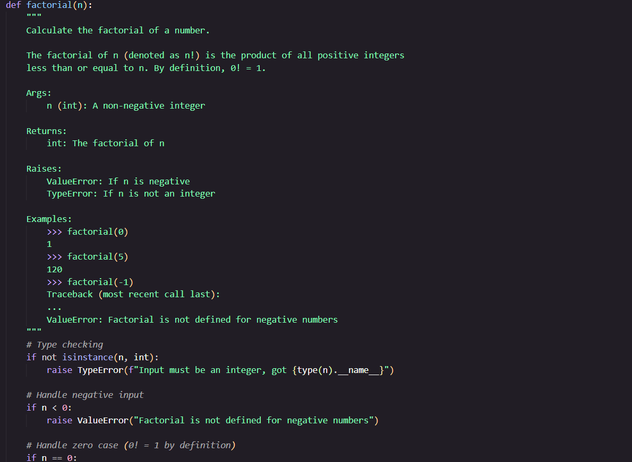 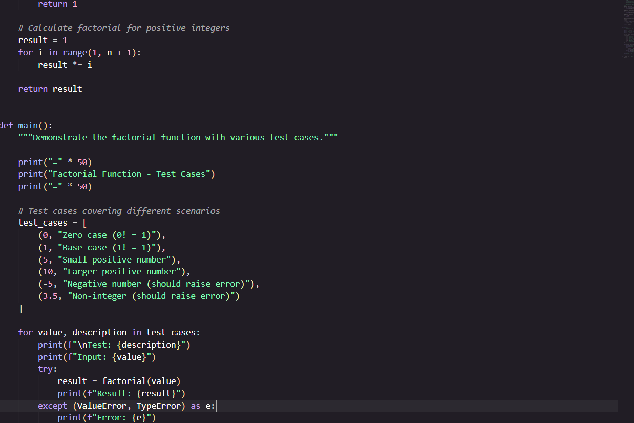 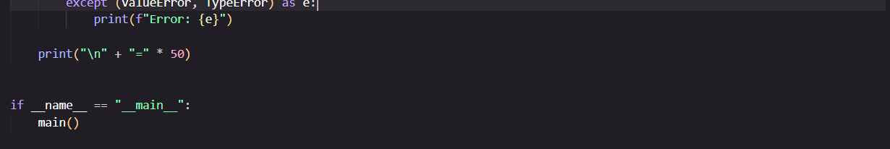
OUTPUT: 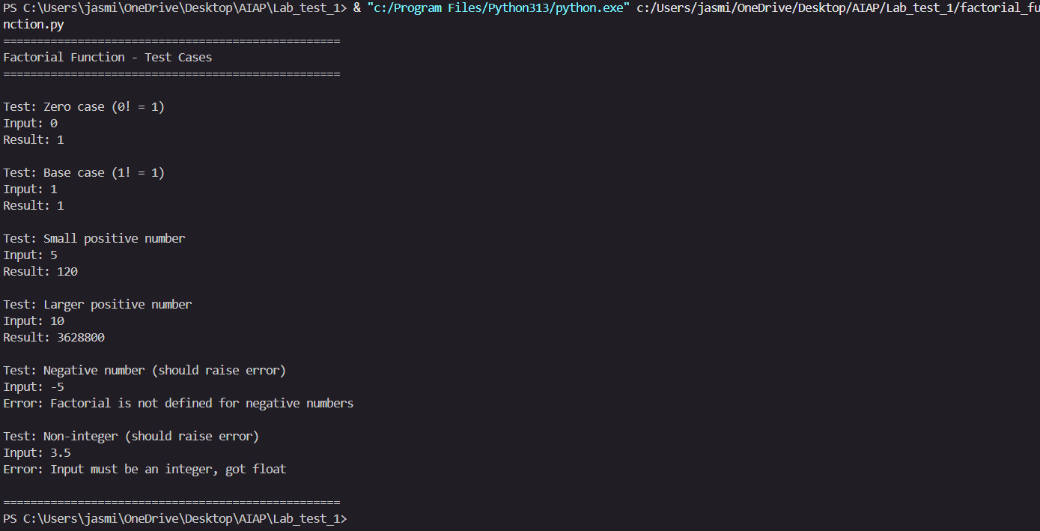
(Each question carries 5 marks)
- Q2. Given a list of student marks, compute the mean and list all students above the mean. Demonstrate zero-shot, one-shot, and few-shot prompts to guide an AI tool to solve this. Summarize the differences in approach.
PROMPT: Given a list of student marks, compute the mean and list all students above the mean. Demonstrate zero-shot, one-shot, and few-shot prompts to guide an AI tool to solve this. Summarize the differences in approach.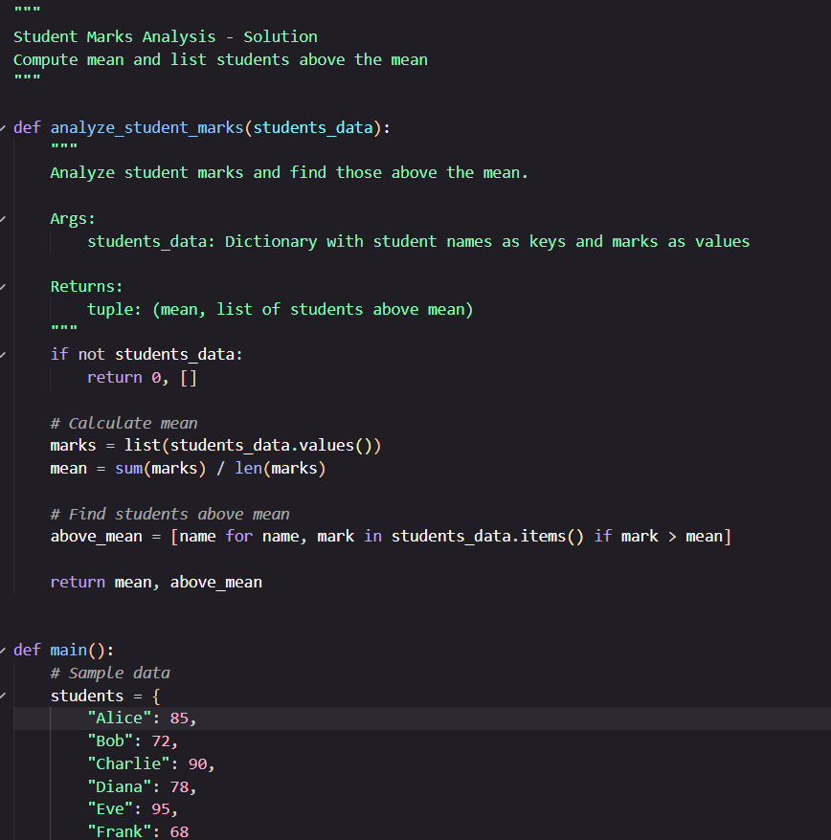 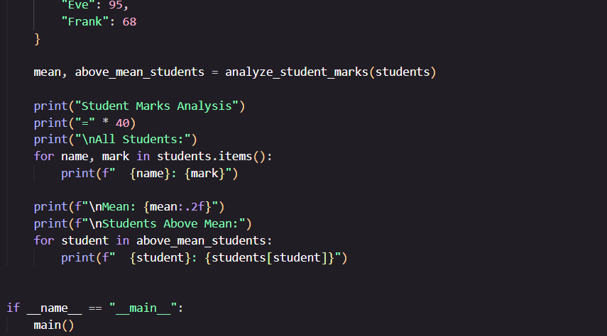
OUTPUT: 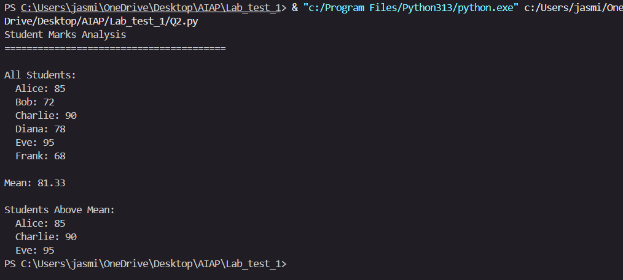
(Each question carries 5 marks)

Set 2
- Q1. Write a Python function `is_prime(n)` to check if a number is prime. Use an AI coding tool to generate and justify a set of test cases before implementation. Pass all generated test cases.
(Each question carries 5 marks)
- Q2. Develop a Python class `Rectangle` with methods for area and perimeter. Use an AI assistant for auto-generating docstrings and inline comments. Compare them with your manual documentation.
(Each question carries 5 marks)

Set 3
- Q1. Implement a Python class for a stack data structure (`push`, `pop`, `peek`). Use GitHub Copilot to generate code, test its handling of edge cases, and explain any improvements made.
(Each question carries 5 marks)
- Q2. Refactor a poorly commented Python function using an AI assistant for automatic documentation. Evaluate clarity and completeness versus manual comments.
(Each question carries 5 marks)

Set 4
- Q1. Create a function to reverse a list in Python. Use an AI tool to suggest alternative implementations. Test and compare the performance of each version.
(Each question carries 5 marks)
- Q2. Design a few-shot prompt to guide an AI tool in writing code for a basic linked list with methods for insert and delete. Analyze the resulting code for correctness and completeness.
(Each question carries 5 marks)

Set 5
- Q1. Generate Python code for the Fibonacci sequence with Cursor AI. Refine your prompts to handle only positive integers and record the changes and outcomes.
(Each question carries 5 marks)
- Q2. Write a Python queue class (`enqueue`, `dequeue`, `peek`). Use an AI assistant and test the class with multiple scenarios. Describe how AI-generated code manages edge cases and how you improved it.
(Each question carries 5 marks)

